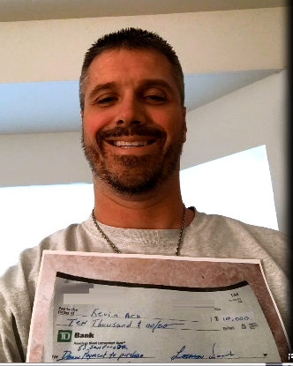
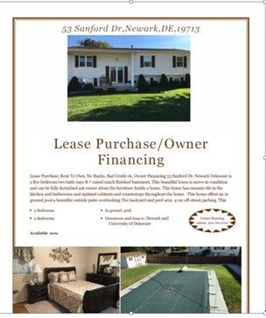
My first deal
I ordered Ron's course the end of September, and went to quick start training the second week of December. And here is my first deal that I closed out December 17. The property is located in Newark Delaware it's a pretty house five bedroom two bath finished basement fenced in backyard with a inground pool which I picked up on a lease option for what the seller owed on the property which was about $226,000 I then with a monthly payment of about $1600 a month. I sub-leased it to a tenant buyer, got $15,000 down, and they gave me a check for $10,000 and the balance of $5000 is due Jan 1st with the rent. They are paying $1700 a month and a purchase price of $250,000. I am already working on my next deals to lead me to Financial freedom. Thanks, Ron!

