I have had a small but limited real estate prior to finding Ron LeGrand. I own a 4-plex and a vacation rental cabin in the Smokies, but I knew there was so much more to real estate. Money was the biggest concern, along with liability and the stress of the unknown that could ruin you. Spending time now with Tony Pearl as my mentor has been like waking up from the fake world into the real world (Like the movie "The Matrix"). Tony has been very attentive and instructive to me. He has a vast store of experience to guide me through the jungle. He is truly and altruistically a fantastic mentor that I thank God for the opportunity to have found him and this program. I just got my first contract with a seller signed this weekend and I'm so excited that I'm tripping over myself with what to do. Tony is a calming and guiding mentor that keeps me on track and is not afraid to tell me the truth I need to grow - which I appreciate most. I'm on the way to becoming a successful real estate investor, I can taste it. It just takes a little patience and commitment. My take on the mentorship program is such: If you really want to succeed in this business and change your life - you need to go all in and get a mentor. All the classes and seminars you will spend money on are a waste, if you do not get a mentor. Your dreams live on the other side of your fears. Thanks again to Tony, a wonderful man, and a caring mentor!

Sincerely,
Jorge Santana
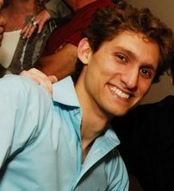
New Orleans, LA

