May 1, 2018

Hi Barbara,
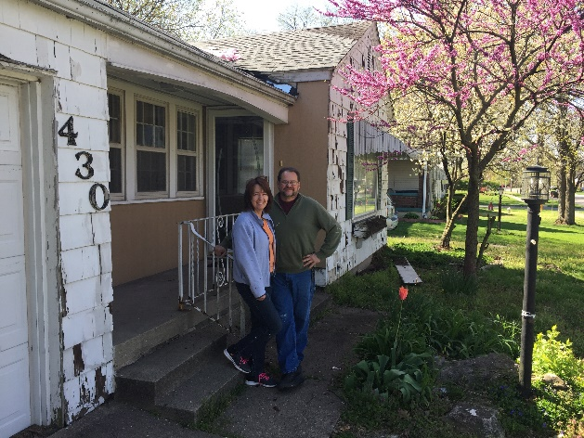
We signed up for mentoring and attended Ron LeGrand’s Real Estate Summit in 2018. We have closed on 3 houses and have 5 under contract in three months.
The first house we bought after being in the program was 919 S. Center, a cute little Victorian shotgun house at an auction for $19,000. We will put $20,000 in repairs for rehab and then sell it for $91,000.
The second house we bought was on Washington St. We bought it on contract for $45,000 with $1,500 down. Our payment is $400. We sold it that afternoon for $60,000 to a couple who put down a $4,000 deposit. They love the house. It needed no repairs. Their payment is $575 so it cash flows $175 per month.

The house in the picture we bought it for $53,500 with $5,000 down and payments of $600 per month and we will need to put about $10,000 in it and about 3 weeks worth of work. We will be able to sell it for $89,500 with $8,900 down, so we will get $250 positive cash flow each month for 3 years which totals $9,000 plus $17,600 on the back end for a total profit of $26,600 for this house.

Thanks for the instruction and guidance,

J.R. and T.K. Wilson
InitialNetworks,LLC

