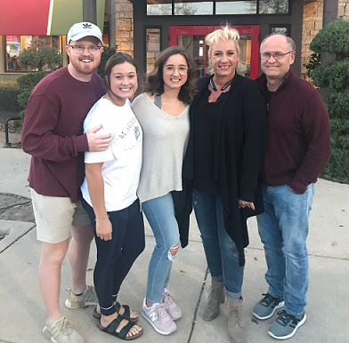
Hi Ron,

I'm so excited to be able to say thank you for all you've taught me! You're one of the most quoted men in my household, while raising my kids, and one of my heroes for sure!

I started with you in January of 2000 and with two little kids and one on the way. You helped us build our business. We had started buying houses with our own money and credit, but then we met you! We could buy houses with no money or credit and it really worked! I was a young mother of 3, my husband is deaf and worked at the advertising business we owned part of. His check really became an afterthought, but he loved what he did.

Everything was going really well until 2008, when the foreclosures in Texas started. I couldn't unload my 20 properties - many of them had plummeted in value and had tenant buyers living in them, who now couldn't pay. Because of all the money I had in the bank and very little debt, I thought I was bullet proof and could weather the storm. Sadly, I was mistaken.

I only knew how to do pretty houses and if I had done what you always told us (ugly houses for cash flow) we may have gotten through It, but instead we used all of our six figures in the bank and sold our home that was paid off just to try to keep the million dollars in equity in our houses and make all the payments. Simultaneously, our business partners embezzled everything from our advertising business so both income streams stopped at once and Instead we lost it all.

In 2013, I dusted myself off and went to a convention - you called me a reptile brain on steroids - and I knew I could rebuild! You gave me hope again! I had never failed at business before and I felt like a failure. We had started another business and were on a trial with the embezzlement, so we had to flip houses just to make it.

We've flipped (wholesale and retail) many houses in the past few years and are getting back on our feet. I would like to do many more then we're doing now, but we're getting there.

I still learn every time I attend one of your seminars and go as often as I can - even when you're in Dallas just for a one-day event. I always leave with one nugget I forgot about or haven’t heard before. I'm so thankful for you and your generosity to show us all the way!
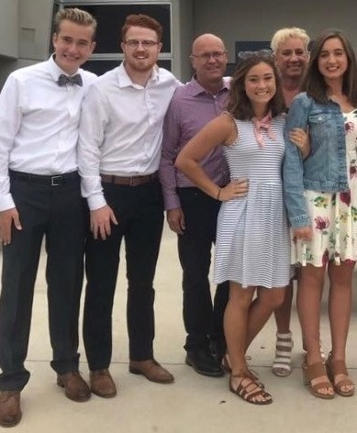
I quote you all the time at my house and anyone who knows me well knows your name! You’re one of my heroes for sure!

Thanks for everything! Keep on teaching!
Debbie Wood

