After attending two different Fast Track days, I finally ‘bit the bullet’ and got to a Quick Start Real Estate School in Chicago, IL. From there I signed up for the mentoring program and was assigned to Barbara LeGrand Cockrell (yes – Ron’s sister).
Barbara has been a great resource of information which filled in some blank spots in my head regarding the Lease Option/Rent-to-own process. She has also provided many resources for where to go for leads, as well as advice on the leads and deals, and escrow and screening tools for prospective tenants.
Two things have resulted from signing up for Gold Club leads:
- I was able to purchase a duplex as a source of passive income. The entire process of getting the signed offer to purchase took a phone call on a Tuesday, seeing the property the following Saturday which included making the offer and getting signed acceptance. It’s called being in the right place at the right time.
- I found a house to lease with a purchase option, placed the Craigslist ad and got a rent-to-own buyer within two weeks.
I’ve been a building contractor for seven years and two years ago got involved in the local chapter of the REIA (Real Estate Investors Association). One of the great things about that organization is a local source of knowledge of the real estate market in the area. As a result of joining this group, I began my career of real estate investing by doing ‘flips’.
As ‘they’ say, timing is everything – within a short period of time, I finished my third flip and got it on the market, bought a duplex and got my first lease/rent-to-own deal. I found a buyer for the house and got all the paperwork signed. This deal nets $26,000 in option payments, $100/month in additional rent payments and a yet to be determined amount on the back end.
Needless to say, I’m working on finding the next deal… and the next one… and so on into the future.
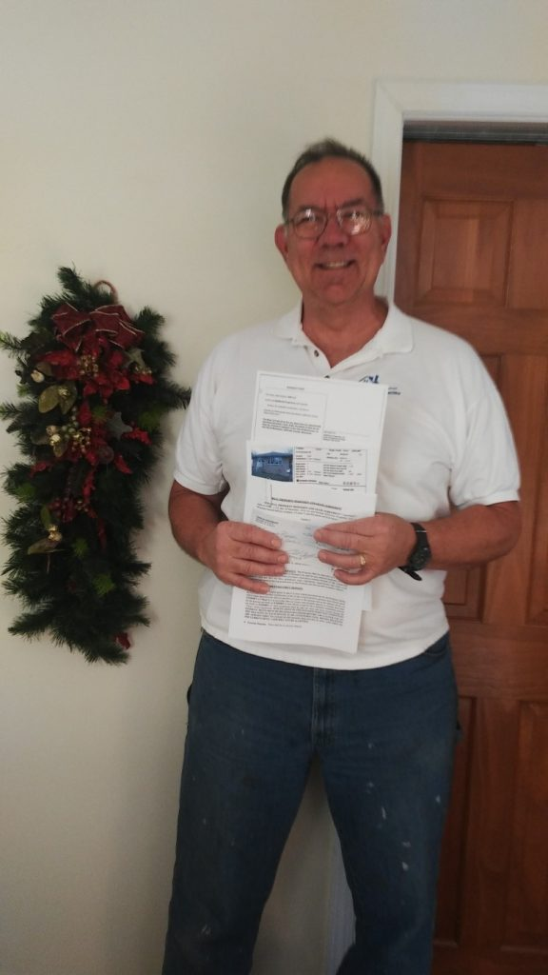
The picture is me holding the deed to the duplex, the MLS data sheet for the ‘flip’ and the signed Rent-to-Own lease and the option payment check.

